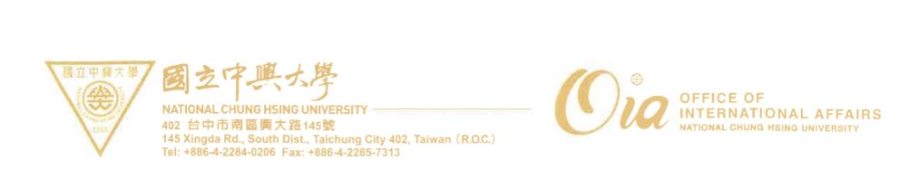
National Chung Hsing University
Declaration of Admission Documents Legalization
□ 2021 Fall Semester

I, __________________________ , applying for ___________________________
(Full name) (Program name)
at National Chung Hsing University, hereby promise that I will submit the following verified documents by , 2021 (GMT+8). Meanwhile, I will submit my provisional certificate to the university first.

Check ( V ) | Items
 | One photocopy of highest level of educational diploma verified by a Taiwan Overseas Representative Office
 | One photocopy of highest level of educational transcript verified by a Taiwan Overseas Representative Office
Please confirm the following items and place a check mark (V) next to those documents to be submitted.

Furthermore, I will bring my original diploma and transcript to National Chung Hsing University. If I cannot submit the copies of the verified documents to the Admissions Section, and cannot have them by above-mentioned date, the qualification of enrollment will be revoked.
Note: If the original documents are not in English or Chinese, an English or Chinese translation notarized by a Taiwan overseas representative office is also required.

Applicant Number：_____________________
Signature of applicant：_____________________
Date：_____ /_____ /_____
（month） （day） （year）

