一張含有 設計 的圖片

描述是以低可信度自動產生

**2026 興大國際處 國際志工 計畫簡章**

**NCHU OIA Int’l Volunteer Program Info**

**1+1方案 國內、國外服務一次滿足！**

**Experience 2 programs at once!**

### 主辦單位：國際事務處

### 協辦單位：中興大學國際志工社

### Organizer: Office of International Affairs & IVC (NCHU Int’l Volunteer Club)

**Collaborative units: International Volunteers Club**

**服務計畫 / Overview**

|  | 臺灣 Taiwan | 寮國 Laos | |
| --- | --- | --- | --- |
| 計畫Program | 山海共好：苗栗棲地保育與海岸守護計畫  Harmony of Mountains and Sea: Miaoli Habitat Conservation and Coastal Protection Program | 寮國兒童教育與社區基礎建設計畫  Laos Children’s Education and Community Infrastructure Program | |
| 服務地點Location | 苗栗通霄、後龍  Miaoli County, Taiwan | 寮國龍坡邦 Sang Hai 村莊  （距離龍坡邦車站約40分鐘）  Sang Hai Village, Luang Prabang, Laos (Approximately 40 minutes from Luang Prabang Railway Station) | |
| 服務時間Workcamp Time | 2026年4月3日(五) - 4月6日(一)  ( 4天3夜 )  Apr.3rd to Apr. 6th, 2026 | 2026年7月1日(三) - 7月15日(三)  ( 15天14夜 )  Jul.1st to 15th, 2026  **機位可能異動，請保留前後10天不安排活動。This date is subject to change. Please leave a 10-day time window open.** | |
| 自付額 Payment | 每人應負擔費用約為新台幣 12,000 至 15,000 元之間，具體金額將依當年度核定經費決定。此外，校方將同步進行對外募款，並根據募款結果減免學生自付費用。  NTD$12,000-15,000 per person, depending on the annual budget. Meanwhile, fundraising will be conducted, and the amount raised will be used to reduce the individual payment accordingly.  **本國籍且符合「高教公共性就學協助獎勵辦法」條件者另有補助。**  **(除身心障礙學生外，延長修業年限者不得申請本獎勵。)** | | |
| \\\要注意的Application Reminder | **報名期限 ： 2025年11月21日 (五) 中午12點止。**  **Application Deadline: Fri., Nov. 21st, 2025, 12:00 noon**  ** 雙計畫都須參加，無法擇一。**  **Those admitted are required to participate in both programs** | | |
| 主體活動 Activity | **走進海岸與農田，參與環境與生態保育行動；從淨灘到雞舍改建，實踐友善土地與野生動物共存的服務精神。**  **環境服務（淨灘）**  於苑裡海岸進行淨灘行動，清理海洋廢棄物並推廣海洋環境教育。  **生態保育（雞舍搭建、撿螺挲草）**  協助石虎協會進行雞舍改建與友善農田維護，促進石虎棲地保護與農民合作。  **教育服務**  於青少年公益機構進行教案宣導，建立友善動物的價值觀。  Step into coastal shores and farmlands, joining hands-on efforts in environmental and ecological conservation. From beach cleanups to rebuilding chicken coops, this is a volunteer journey of coexisting with nature and wildlife.  **#Environmental Service (Beach Cleanup**)  Conduct beach cleanups along the coast of Yuanli, removing marine debris and promoting ocean conservation education.  **#Ecological Conservation (Chicken Coop Building & Grass Removal)**  Support the Leopard Cat Association in rebuilding secure chicken coops and maintaining eco-friendly farmland to protect wildlife habitats and foster collaboration with local farmers.  **#Educational Service**  Deliver educational workshops at youth welfare institutions to promote values of animal friendliness and ecological awareness. | | 在寮國偏鄉用心傾聽，我們給的不多，卻將帶回一段改變自己的旅程。  **兒童 & 青少年教育：**  主要服務對象為村落中小學生與中學生，課外(室內)主題教學。(由當地開出需求，我方設計課程)  **協助提升當地教師英文能力：**  當地教師人數不足，英文教學資源有限，如能提升他們語言能力，對於孩童的學習將更有助益。  **基礎建設：**  彩繪、搭建或翻修當地社區、學校基礎建設 (圍牆或圖書館)。  **文化探訪：**  深入探訪古蹟與近郊都市。  In the rural villages of Laos, we learn to listen with intention. What we give may be modest, but what we take home is a journey that transforms us.  **#Children & Youth Education**  Serve local elementary and middle school students through themed indoor workshops tailored to community needs.  **#Teacher Capacity Building**  Support local teachers in improving their English skills, enhancing the long-term learning environment for children.  **#Community Infrastructure Construction**  Participate in painting, building, or repairing basic facilities such as school fences or libraries to improve community spaces.  **#Cultural** **Exploration**  Engage in meaningful visits to historical sites and nearby towns to deepen understanding of Lao culture and context. |

**以上行程、日期、天數皆有可能因實際操作而有所改變，以最新資訊公告為主。**

**This schedule, date, and days are subject to change.**

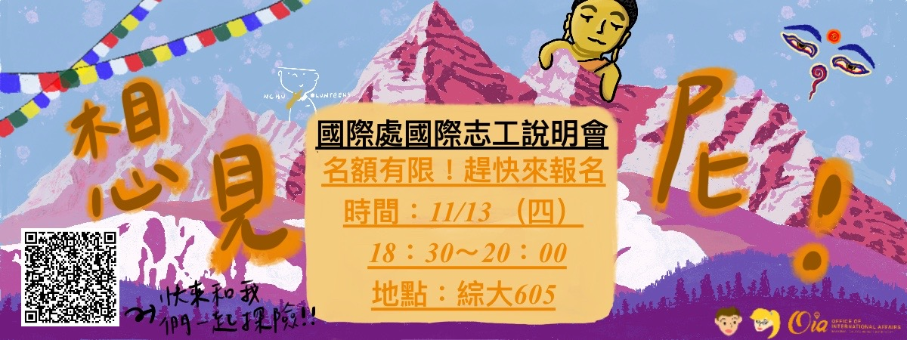

**其他注意事項 / Important Reminder**

錄取後即為國際志工社社員，除必須配合參與以下事項外，也須執行社員義務參與社團活動如志工週、分享會等籌備。

1. 錄取後即刻開始和隊員協力準備計畫，包括教案設計(規劃每週進度)、參加行前訓練及每週社課、行政工作，及各項相關會議與討論。
2. 服務結束後，協助引導下一屆國際志工及社團運作。
3. 活動結束後一個月內，須繳交 1,500 字參與心得，並參與公開成果分享會。
4. 請確實取得監護人/指導教授/家長等人同意，錄取後將簽署服務同意書。
5. 錄取後請繳交保證金新臺幣 3,000 元，全程參與 2 個工作營與其他活動 (包括但不限於行前訓練、社課等) 出席率超過80%即全數歸還。

If accepted, students will automatically become members of the International Volunteer Club and will be required to participate in club activities such as organizing Volunteer Week and presenting at the sharing sessions.

1. After receiving admission notice, students will start to prepare for the program immediately, including designing teaching materials, participating in pre-departure drills, weekly classes, and other team meetings.
2. Help guide new club members of the next generation and assist in club affairs.
3. Submit a written review (at least 1,500 words) within one month after the program ends and join the oral presentation.
4. Must inform and gain your guardian, advisors, or your parents’ permission. After admission, consent letters must be signed.
5. A deposit of NT$3,000 in cash is required if one is admitted. Full participation in 2 work camps listed on page 1 and over 80% attendance in other activities (including but not limited to pre-trip training, classes, etc.) will be fully refunded.

|  |
| --- |
| **報名窗口**  [**請將報名表及其他加分文件寄至 國際處-國際教育組 黃小姐pacihuang@email.nchu.edu.tw**](mailto:請將報名表及其他加分文件寄至%20國際處-國際教育組%20黃小姐pacihuang@email.nchu.edu.tw) **/ 04-22840206*41**  **Where to hand in online application?**  Ms. Huang, Coordinator of Division of International Education, OIA  **Email your application to** [**pacihuang@email.nchu.edu.tw**](mailto:pacihuang@email.nchu.edu.tw)/ 04-22840206*41 |
| **招募對象**  **中興大學在學學生**  **具備社團活動經驗、服務隊或志願服務學習經驗者尤佳。**  # 外籍同學也OK！會中文加分+++  # 美術、靜態動態攝影專長，加分++！ \\有作品集更棒//  **Who Can Apply?**  National Chung Hsing University students, and those that have student clubs or volunteer experiences are more than welcome. The ability of Chinese listening and speaking is a plus.  **# Foreign students who can speak Mandarin is very welcome.**  **# Expertise in art and photography are a plus.** |
| **徵選原則**  **採兩階段**  第一階段為書面資料審查；第一階段通過者，將另行通知參與第二階段面試，評審標準包括個人特質、社團或志工服務等經驗、外語能力、溝通表達能力、應對能力等。  **Selection Process (Two stages)**  Stage I – Applicants will be selected based on the information provided in the application form.  Stage II – Shortlisted applicants will be invited to have an interview with the Selection Committee. |