
2027 興大國際處 國際志工 計畫簡章
NCHU OIA Int’l Volunteer Program Brochure
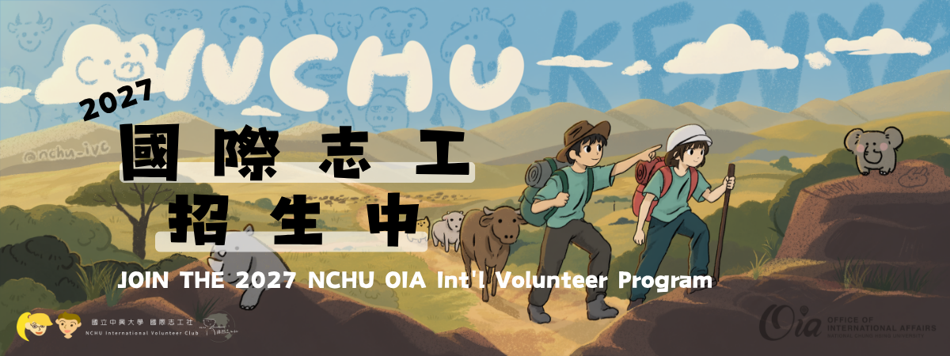

主辦單位：國際事務處

協辦單位：中興大學國際志工社

Organizer: Office of International Affairs & IVC (NCHU Int’l Volunteer Club)
Co-Organizer: National Chung Hsing University International Volunteer Club

服務計畫 / Overview
 | 臺灣 Taiwan | 肯亞 Kenya
計畫Program | 棲地保育與社會關懷服務計畫  Habitat Conservation and Social Care Service Program | 肯亞兒童教育與社區基礎建設計畫  Kenya Children’s Education and Community Infrastructure Program
服務地點Location | 苗栗通霄、後龍  Miaoli County, Taiwan | 肯亞奈洛比與基貝拉  Nairobi and Kibera, Kenya
服務時間Workcamp Time | 2027年4月3日(六) - 4月6日(二)  ( 4天3夜 )  Apr.3rd to Apr. 6th, 2027 | 2027年7月1日(四) - 7月12日(一)  ( 12天11夜 )  Jul.1st to 12th, 2027  機位可能異動，請保留前後10天不安排活動。This date is subject to change. Please leave a 10-day window open.
自付額 Payment | 每人應負擔費用約為新台幣 21,000 至 25,000 元之間，具體金額將依當年度核定經費決定。  Approximately NT$21,000–25,000 per person; the exact amount will be determined based on the approved budget for the year.  本國籍且符合「高教公共性就學協助獎勵辦法」條件者另有補助。  (除身心障礙學生外，延長修業年限者不得申請本獎勵。)
\\\要注意的Application Reminder | 報名期限 ： 2027年11月23日 (週一) 中午12點止。  Application Deadline: Mon., Nov. 23rd, 2027, 12:00 noon   雙計畫都須參加，無法擇一。  Those admitted are required to participate in both programs
主體活動 Activity | 走進海岸、農田與社區，從實際行動認識環境、生態與社會議題。  環境服務（淨灘）  於苑裡海岸進行淨灘行動，清理海洋廢棄物並推廣海洋環境教育。  生態保育（雞舍搭建、撿螺挲草）  協助石虎協會進行雞舍改建與友善農田維護，促進石虎棲地保護與農民合作。  社會關懷服務  依公益機構及服務對象需求，由志工團隊共同規劃手作、遊戲等互動活動，進行一日陪伴服務。  Step into coastal areas, farmlands, and local communities to explore environmental, ecological, and social issues through hands-on service.  #Environmental Service (Beach Cleanup)  Join a beach cleanup in Yuanli to remove marine debris and promote awareness of marine environmental protection.  #Ecological Conservation (Chicken Coop Construction & Farmland Maintenance)  Assist the Leopard Cat Association with chicken coop renovation and wildlife-friendly farmland maintenance, supporting leopard cat habitat conservation and collaboration with local farmers.  #Community Care Service  Based on the needs of nonprofit organizations and the people they serve, volunteers will work together to design hands-on crafts, games, and other interactive activities for a one-day community service program. |  | 踏上東非赤道高原與紅土大地，我們跨越語言與文化，在陪伴與勞作中拓展彼此的生命視野。  兒童與青少年教育  深入 Kibera 小學，依年齡分層設計多元主題課程，涵蓋中英文遊戲、趣味活動、體育互動與主題園遊會。  基礎建設改善  依照校園與社區實際需求，參與教室與圖書館油漆粉刷、簡易修繕與搭建工程，協力打造更安全的學習環境。  衛生教育與青年交流  推廣洗手、潔牙等日常衛生觀念；並透過文化分享、傳統童玩與生活互動，與在地青年及孩童建立真摯的跨國友誼。  農事勞動與城市文化探訪  走入農業大學農場體驗畜牧與環境維護，並探訪肯亞首都奈洛比市區，走入在地街區與日常生活，全方位認識真實的東非人文脈絡。  Across the equatorial highlands and vibrant red plains of Kenya, we bridge cultures and borders—broadening horizons through meaningful connection and hands-on service.  #Children & Youth Education  Serve students at Kibera Primary School through age-tailored workshops, including games, sports activities, interactive learning, and themed carnival.  #Community Infrastructure Construction  Support local schools and communities through painting, light renovations, and repairing spaces like classrooms and libraries to improve the daily learning environment.  #Hygiene Education & Youth Exchange  Introduce foundational hygiene practices such as handwashing and oral care, while building authentic global connections through cultural sharing and peer exchanges.  #Agricultural Labor & Urban Exploration  Engage in hands-on farm and livestock care at an agricultural university, complemented by an in-depth exploration of downtown Nairobi to immerse in everyday local life and East African culture.
以上行程、日期、天數皆有可能因實際操作而有所改變，以最新資訊公告為主。
This schedule, date, and days are subject to change.

注意事項 / Important Reminder
錄取後即為國際志工社社員，除必須配合參與以下事項外，也須執行社員義務參與社團活動如志工週、分享會等籌備。
- 錄取後即刻開始和隊員協力準備計畫，包括教案設計(規劃每週進度)、參加行前訓練及每週社課、行政工作，及各項相關會議與討論。
- 服務結束返國後，需接任社團幹部協助引導下一屆國際志工及社團運作。
- 活動結束後一個月內，須繳交 1,500 字參與心得，並參與公開成果分享會。
- 請確實取得監護人/指導教授/家長等人同意，錄取後將簽署服務同意書。
- 錄取後請繳交保證金新臺幣 3,000 元，全程參與 2 個工作營與其他活動 (包括但不限於行前訓練、社課等) 出席率超過80%即全數歸還。

If accepted, students will automatically become members of the International Volunteer Club and will be required to participate in club activities such as organizing Volunteer Week and presenting at the shared sessions.
- After receiving admission notice, students will start to prepare for the program immediately, including designing teaching materials, participating in pre-departure drills, weekly classes, and other team meetings.
- After completing the service program and returning to Taiwan, students will have to become committee members, help guide new club members of the next generation and assist in club affairs.
- Submit a written review (at least 1,500 words) within one month after the program ends and join the oral presentation.
- Must inform and gain your guardian, advisors, or your parents’ permission. After admission, letters of consent must be signed.
- A deposit of NT$3,000 in cash is required if one is admitted. Full participation in 2 work camps listed on page 1 and over 80% attendance in other activities (including but not limited to pre-trip training, classes, etc.) will be fully refunded.

報名窗口Registration Contact
請將報名表及其他加分文件寄至 國際處-國際教育組 黃小姐pacihuang@email.nchu.edu.tw / 04-22840206*41

Where to hand in online application?
Ms. Huang, Coordinator of Division of International Education, OIA
Email your application to pacihuang@email.nchu.edu.tw / 04-22840206*41
招募對象 Recruitment Targets
中興大學在學學生
具備社團活動經驗、服務隊或志願服務學習經驗者尤佳。
# 外籍同學也OK！會中文加分+++
# 美術、靜態動態攝影專長，加分++！ \\有作品集更棒//

Who Can Apply?
National Chung Hsing University students, and those that have student clubs or volunteer experiences are more than welcome. The ability of Chinese listening and speaking is a plus.
# Foreign students who can speak Mandarin is very welcome.
# Expertise in art and photography are a plus.
徵選原則Selection Principles
採兩階段
第一階段為書面資料審查；第一階段通過者，將另行通知參與第二階段面試，評審標準包括個人特質、社團或志工服務等經驗、外語能力、組織能力等。

Selection Process (Two stages)
Stage I – involves a review of written materials. Applicants who pass Stage I will be notified separately to participate in the Stage II interview
Stage II – Shortlisted applicants will be invited to have an interview with the Selection Committee.

